Kylin250 OSD Set Up Guide

Thank you for purchasing the Kylin250, This guide will explain how to set up the OSD comes with your Kylin250.

First, you will need a USB TO TTL device, the device should have the RTS connector and 5V power supply. Yellow jumper showing in Figure 1 is the 3.3V and 5V voltage selection jumper.
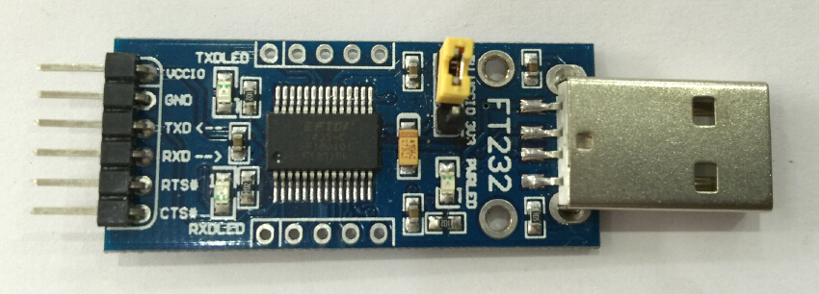
Figure 1
USB to TTL Functions：
VCCIO: Power. Make sure to select 5V using the yellow jumper
GND: Ground
TXD: Transmit Data
RXD: Receive Data
RTS#: Reset
Before configure the OSD you need to disable it under the CC3D, otherwise the OSD can’t be set. Connect the Kylin250 to your PC via USB, start the OpenPilot GCS software. Go to the configuration tab and disable the OSD as showing in the Figure 2. (Kylin250’s integrated OSD is using the Flexi Port of the CC3D, this is factory fixed and cannot be changed. Select any other option on the Flexi Port will result the OSD stop working.) Click Save after you disabled the Flexi Port, then close the GCS and disconnect the Kylin250.

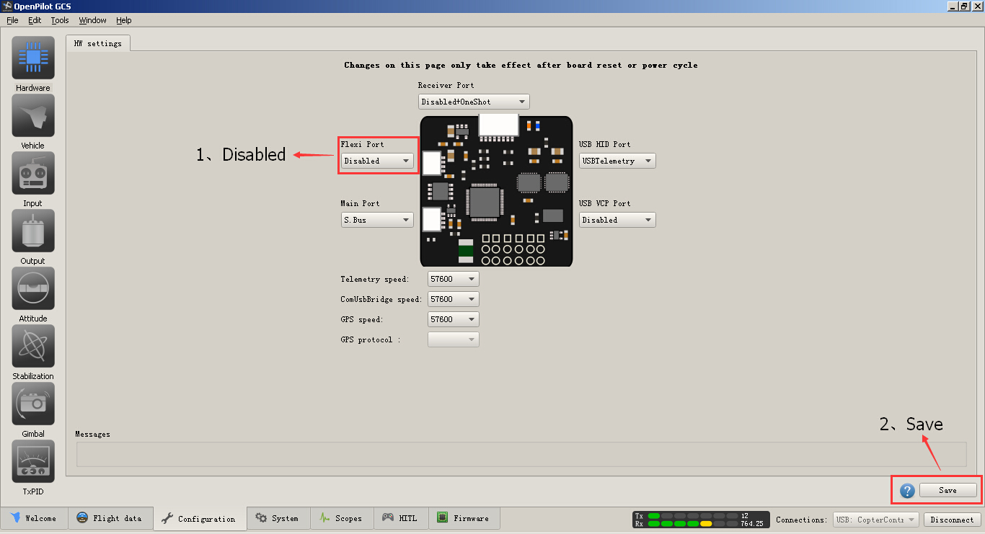
Figure 2
You will need a 5 pin 1mm JST plug to 5 pin 2.54mm socket cable to connect the USB TO TTL device to the Kylin250’s OSD set port, see Figure 3 below:
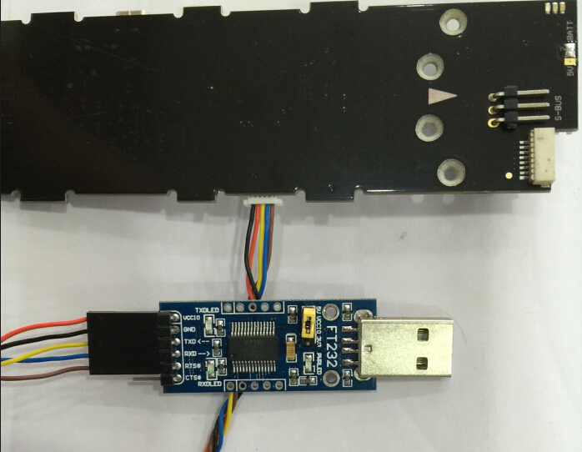
Figure 3
Make sure all wires are connected correctly, then plug the USB TO TTL device to a PC, start the OSD Config software (Can be downloaded from https://code.google.com/p/arducam-osd/wiki/OSD_Config_Tool), see Figure 4:
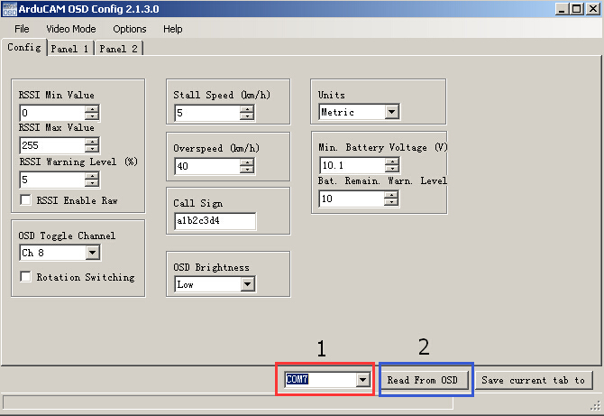
Figure 4
Select the COM port your USB TO TTL device is mapped to, then click “Read From OSD” button, it will pop up a window saying “Done downloading data!” after read the configure from the Kylin250 successfully, see Figure 5:
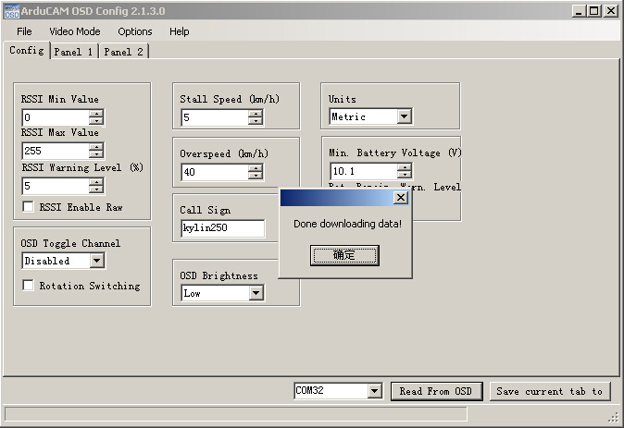
Figure 5
If unsuccessful it will show as in Figure 6:
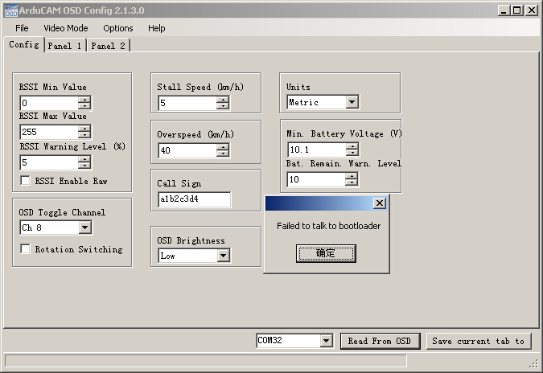
Figure 6
The possible reasons of unsuccessful reads are:
- The device driver of the USB TO TTL hasn’t been installed correctly, please double check with your device supplier.
- The cable between the OSD set port of the Kylin250 and the USB to TTL device is not connected properly, please double check your connection according to Figure 3.
- The COM port of the USB TO TTL device is not selected correctly under OSD Config software, check the Device Manager of your PC to ensure the correct COM port number is selected, see Figure 7:
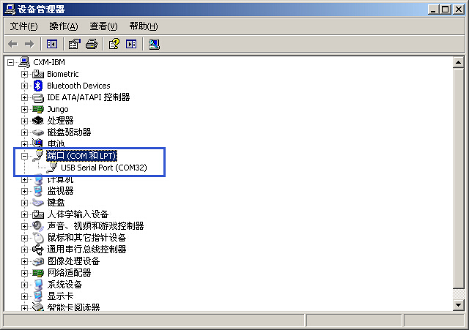
Figure 7
Configure the OSD:
The OSD is an open source project, some functions may not be available to the Kylin250.
OSD’s setting menu is divided into three parts: CONFIG, PANEL1 and PANEL2, as show in Figure 8, 9 and 10.
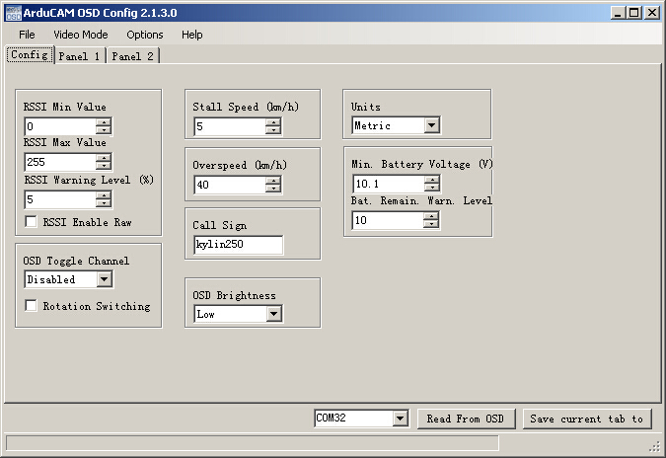
Figure 8
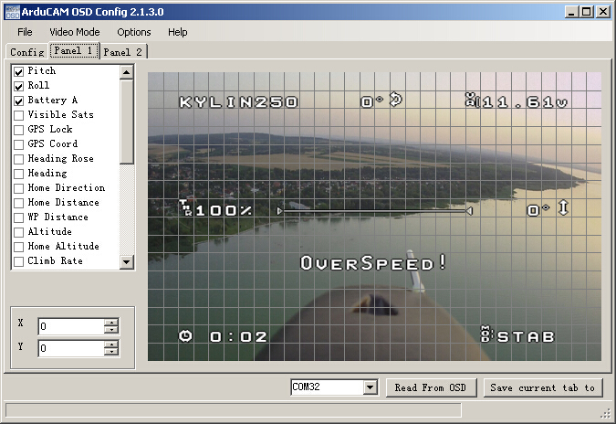
Figure 9
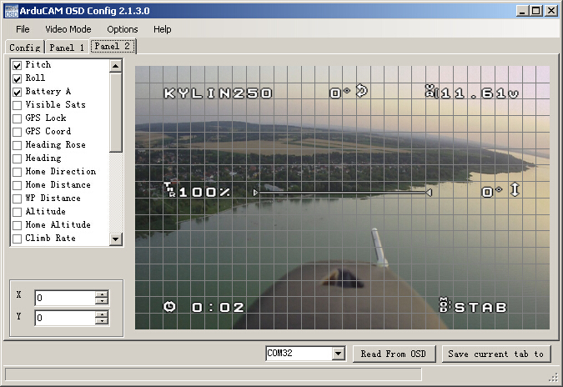
Figure 10
Attention: You have to save the three tabs individually by click “Save current tab to“ button at the bottom right corner. Each button will only save the current configuration of that tab. For example click the button under CONFIG tab will only save the settings of the CONFIG tab, it won’t save the settings of other two tabs. You will need to click “Save current tab to” button separately after completes the setup of each tab.
1. Choose the video format:
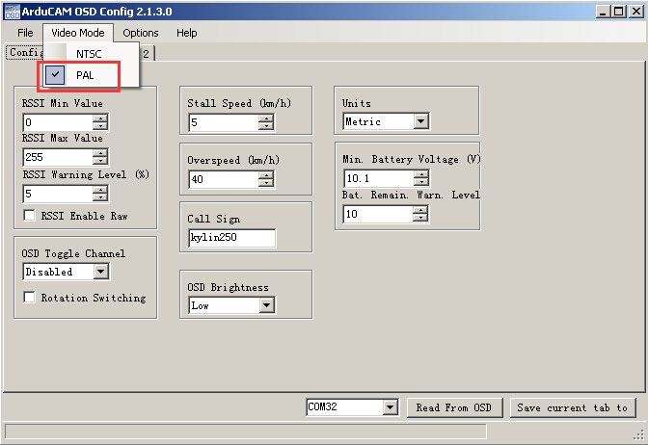
Figure 11
PAL are the most commonly used format, if you choose the wrong format there will be no OSD output.
2. Setup the battery warning voltage:
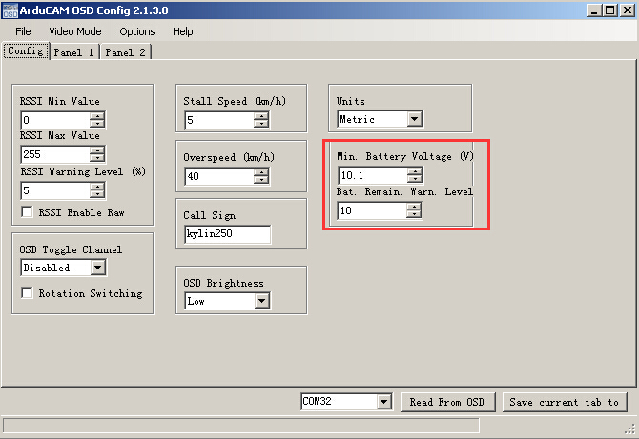
Figure 12
Choose the battery warning voltage warming according to your battery. For Lithium battery, the single cell voltage shall not be less than 3.4V, otherwise the battery will be permanently damaged. The minimum Battery Voltage is calculated by multiplied the number of cells by 3.4, fill in your value and click Save current tab to button to save the settings.
3. Customize the OSD display options:
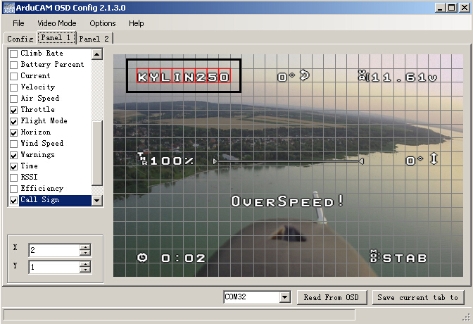
Figure 13
Use mouse to select the check boxes on the left side according to your needs. Selected option will be highlighted in red at the right side sample field, as show in Figure13. Use your mouse to drag the filed to the position you prefer. Click Save current tab to button to save the settings when finish.
Again: The OSD is an open source project, some functions may not be available for the Kylin250.
After complete the OSD setup, disconnect the Kylin250 from the USB to TTL device.
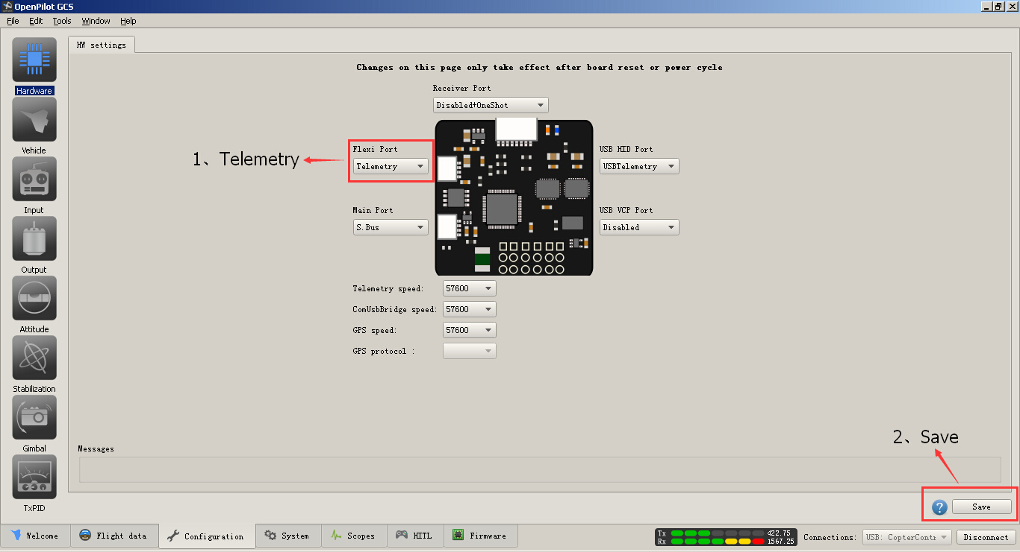
Figure 14
Connect the Kylin250 back with micro USB cable, open the OpenPilot GCS software, when connected, change the Flexi Port option from Disabled to Telemetry under Configuration tab, then click Save. Disconnect the Kylin250 and you are done.

