KYLIN 250FPV Flight Controller Setup Guide

Version 20150903H

This instruction is for setting up the inbuilt CC3D flight controller comes with your KYLIN 250 FPV ARF. For the ARF version, you have to connect and setup the CC3D flight controller with your own radio gear correctly before flying.

Mount the receiver on the upper frame with double-sided tape.

You will need to know exactly what kind of receiver you are using as different receivers request totally different setup steps. Kylin 250 FPV’s inbuilt CC3D supports 4 kinds of receivers, they are PWM, PPM, SBus and DSM.

PWM (Pulse Width Modulation)
This is actually the most common receiver output. The receiver sends a signal of varying length towards the servo or ESC. The length of the pulse specifies the servo output or throttle position. Every servo or ESC has its own connection cable with its own dedicated PWM signal.

PPM (Pulse Position Modulation)
A PPM signal (often referred to as a PPM stream) is basically a series of PWM signals (described above) sent one after another on the same wire. So instead of continuously sending the information for 1 channel or servo, the information for all servo's or ESCs is sent in a row on the same wire. The advantage of such a PPM signal is that only one signal wire is needed instead of all the individual wires.

S.Bus

The S.Bus is another communication protocol from Futaba that can also be used on other radios like Taranis and Radiolink. It also combines all output channel information into single servo lead.

DSM/Spektrum/JR (Satellite connection)
Another receiver option is the Spektrum/JR Satellite. It allows a Spektrum/JR or OrangeRX satellite receiver to be connected to the CC3D.

There are 4 ways to physically connect the receiver to the CC3D:

1. For common PWM receiver, use the multi colored signal wire comes plugged into the PPM/PWM socket of the main board, remove the signal wire on the S.Bus port, here’s the channel order for signal plug:

CH1 | CH2 | CH3 | CH4 | CH5 | CH6
White Red Black | Brown | Orange | Blue | Yellow | Grey

2. For PPM receiver, the WHITE and GREY wire of the multi colored signal wire needs to be swapped FIRST, then connect the GREY RED BLACK plug to the PPM output of your receiver, no other wires need to be connected. See below: 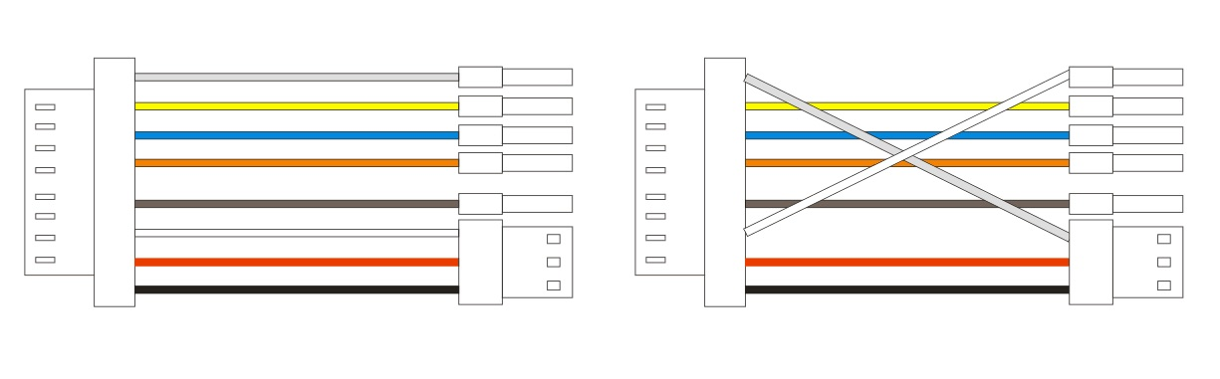
PWM PPM

3. For S.Bus receiver, use the S.Bus signal wire connected to the S.Bus port on the main board, and remove the multi colored PWM/PPM signal cable from its socket.

4. For JR/Spektrum/DSM satellite receiver, plug the signal wire on the satellite to the DSM port on the main board. Then swap the ORANGE and BLACK wire at any end of the plug, see photos below:

- DSM2/DSMX satellite receiver signal wire swap
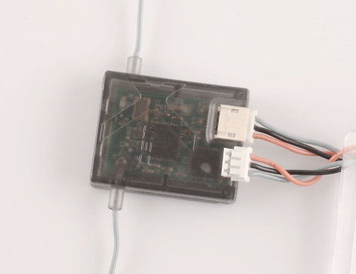

Original DSM2/DSMX Satellite Receiver Wiring
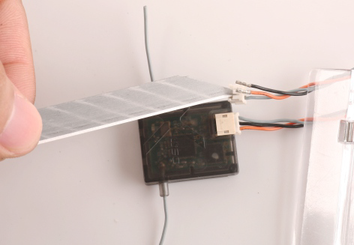

Use knife tip or similar tool to pull the BLACK and ORANGE wire out of the plug and put back in reverse order.

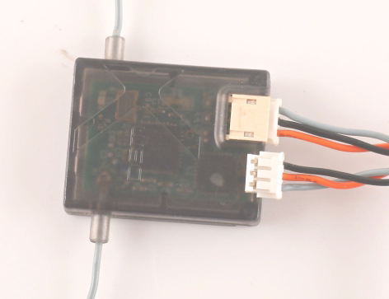
What it should looks when completed.

5. Turn on your radio and create a new fixed-wing airplane model, assign a 3 position switch to channel 5.

After wiring and radio setting, download and install the OpenPilot GCS software to setup the CC3D.

For CC3D setting and instruction please open this link and download
- https://wiki.openpilot.org/display/builds/openpilot+software+downloads

- http://www.kdsmodel.com/manual_en.php
Double click the logo on your desktop to run the OpenPilot GCS after installation.

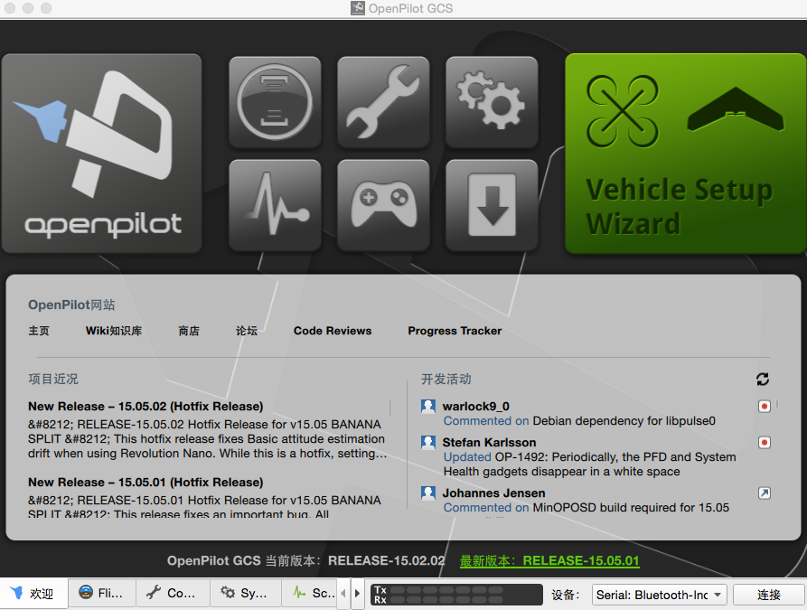
Connect your PC and KYLIN 250 ARF with USB cable. Click the Vehicle Setup Wizard icon 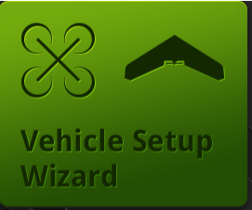 to start the setup.

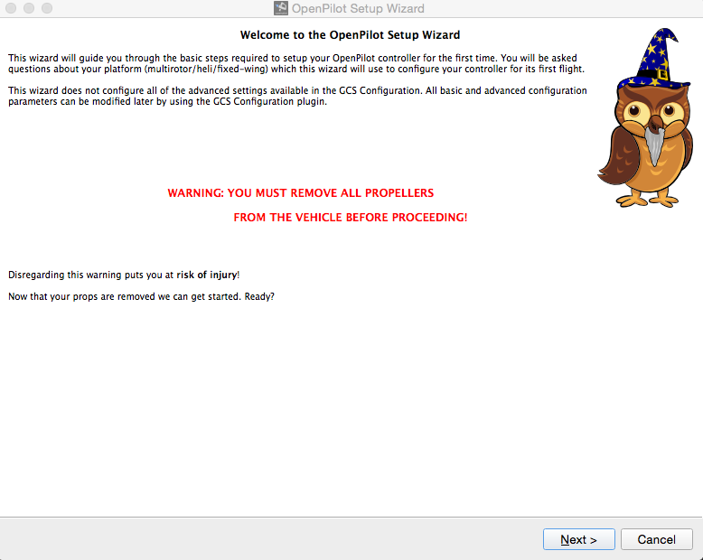

Click “Next” to Firmware Update.

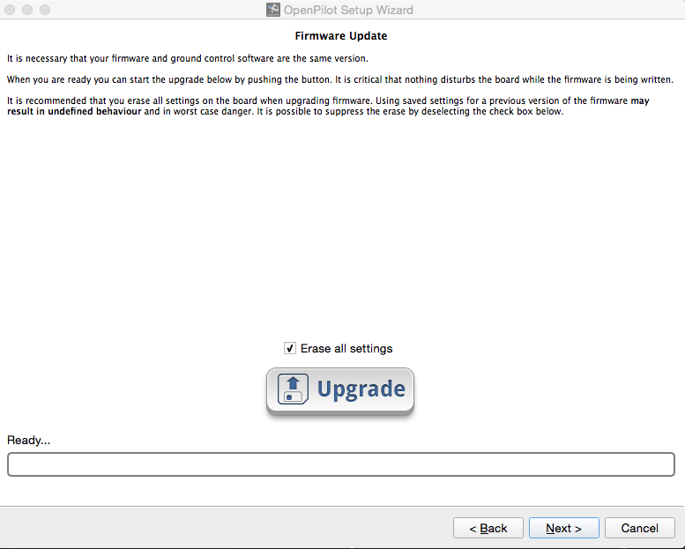

Click “Upgrade”, wait for the progress bar to complete and click “Next”

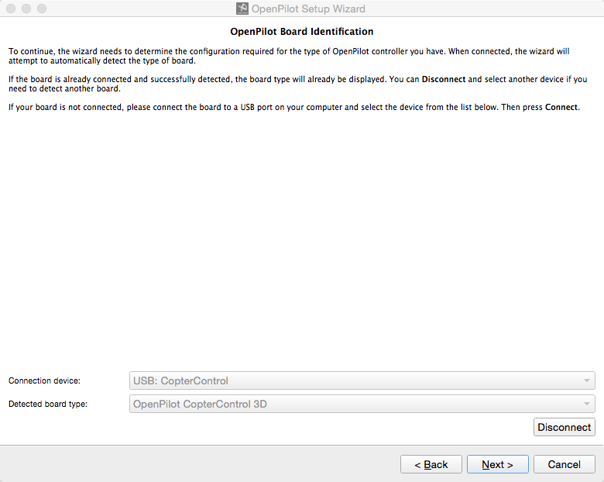
Nothing needs to be changed here, just click “Next”

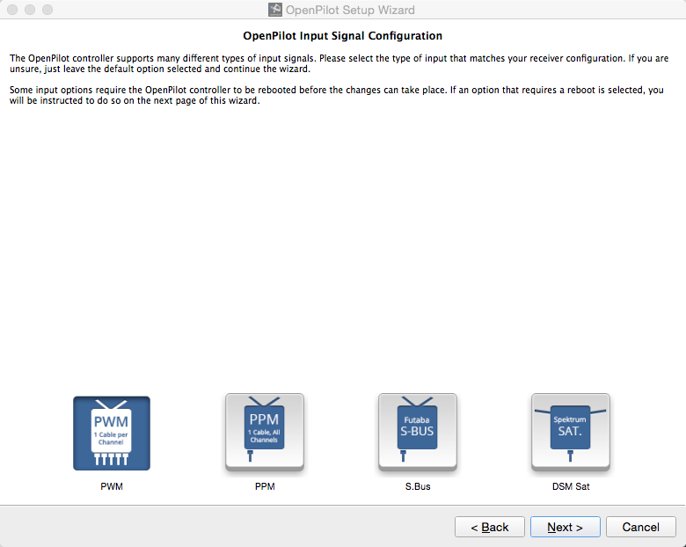
You will be asked to choose the receiver type among four options, please choose your receiver according to the introduction above, if you make the wrong choice here the receiver won’t work. Click “Next”when done.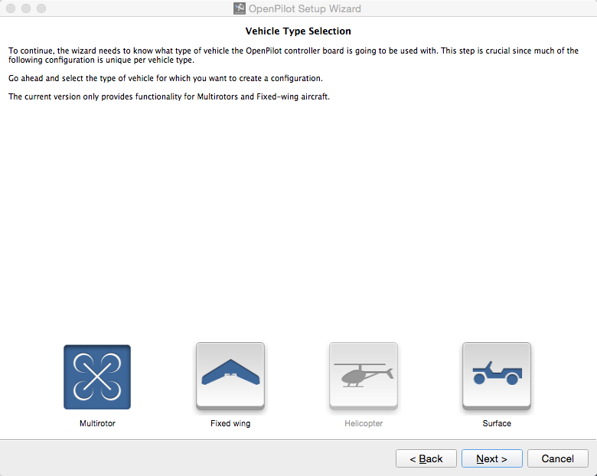

Select “Multirotor” and click “Next”
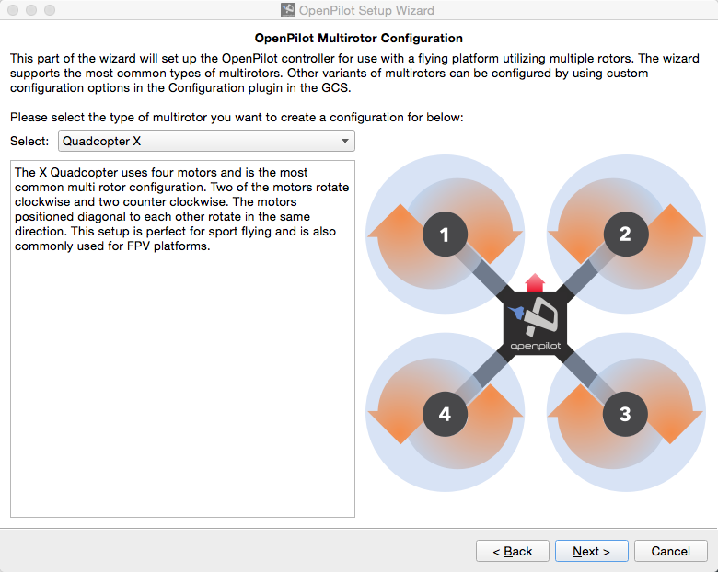
Keep the default “Quadcopter X”, click “Next” to setup ESC
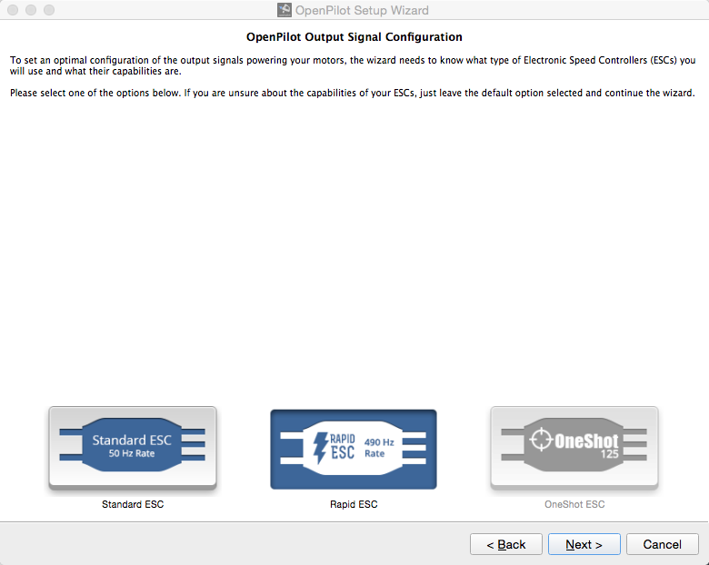

On the ESC menu we have Standard ESC, Rapid ESC and OneShot ESC, the ESCs come with Kylin 250 ARF is OneShot ESC, if you are using PPM,SBUS or DSM receiver the OneShot ESC will be active in blue rather than grey out, choose OneShot ESC and click “Next”. For PWM receiver the stock ESCs cannot be used without following modification:

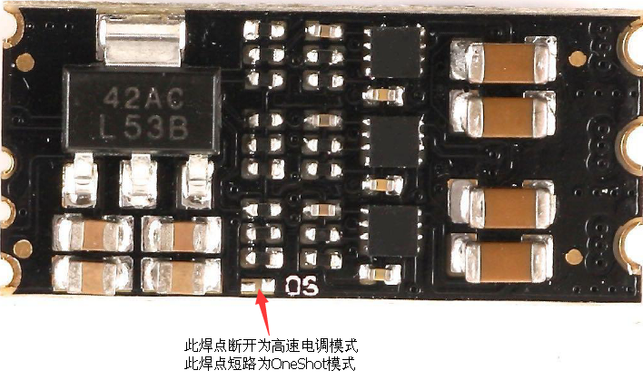

Take off the bottom plate of the Kylin 250, remove the solder jumper with the “OS” mark on PCB with a soldering iron, separating the solder which were originally connected will change the default OneShot ESC to Rapid ESC. Note you need to do this for all 4 ESC modules.

Put the bottom plate back and choose “Rapid ESC” in the configure page.
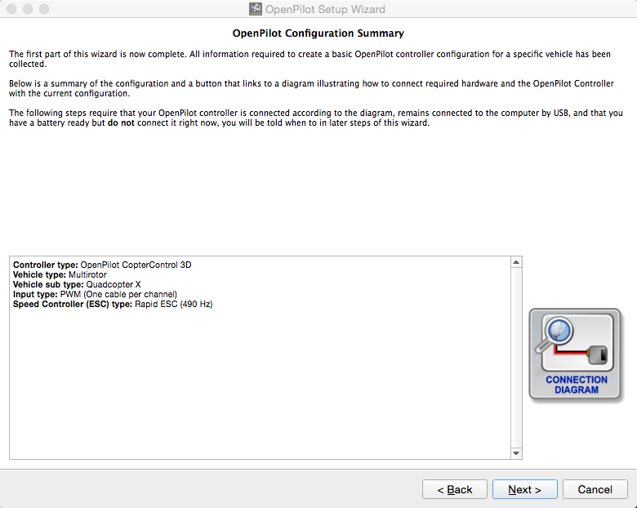

Now the basic configuration has completed, review the settings and click “Next”

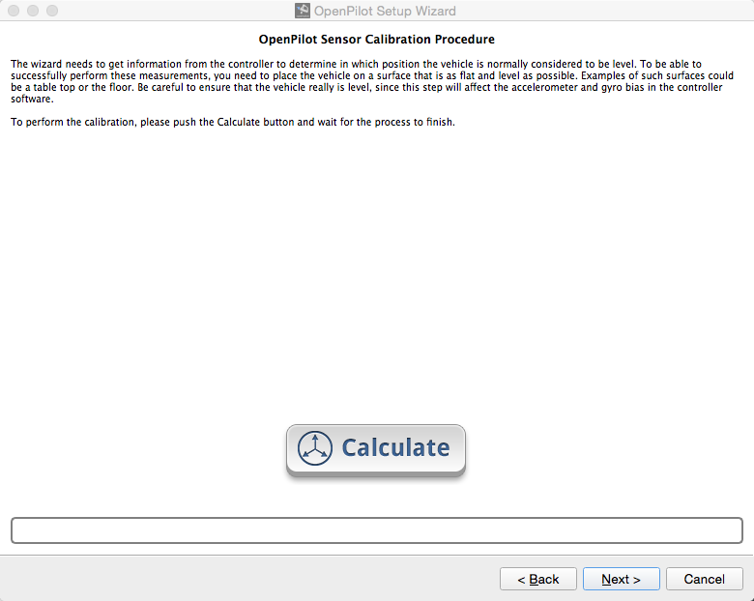

Now will do the sensors calibration for the CC3D. Put the Kylin 250 FPV on a flat surface, click “Calculate” button to start the calibration, and click “Next” when done.

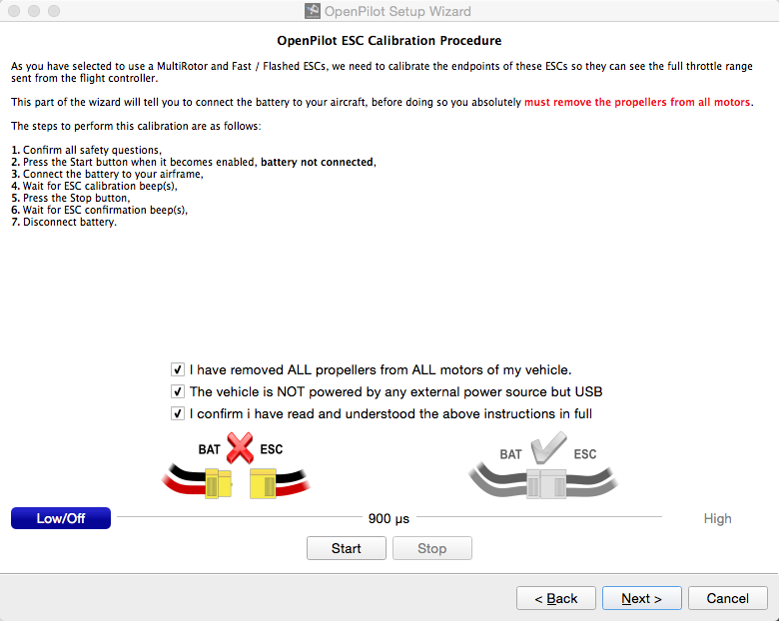

Now we will calibrate the ESC end points. Tick the 3 boxes as showing above, and make sure to follow the instruction steps 1 to 7. Note after step 6 you will have to waiting for the signal back to 900us BEFORE disconnect the battery.

Click “Next” to calibrate on ESC output
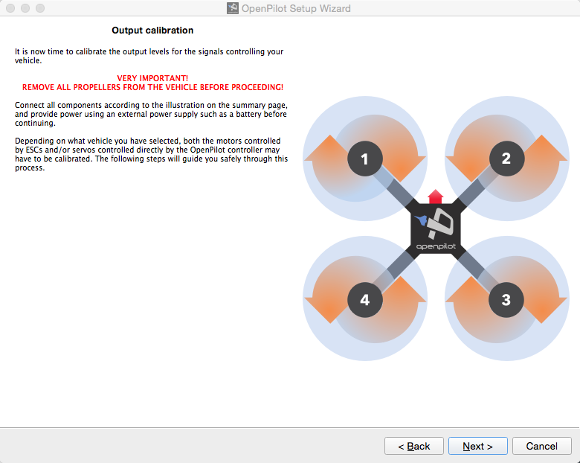
Click “Next”
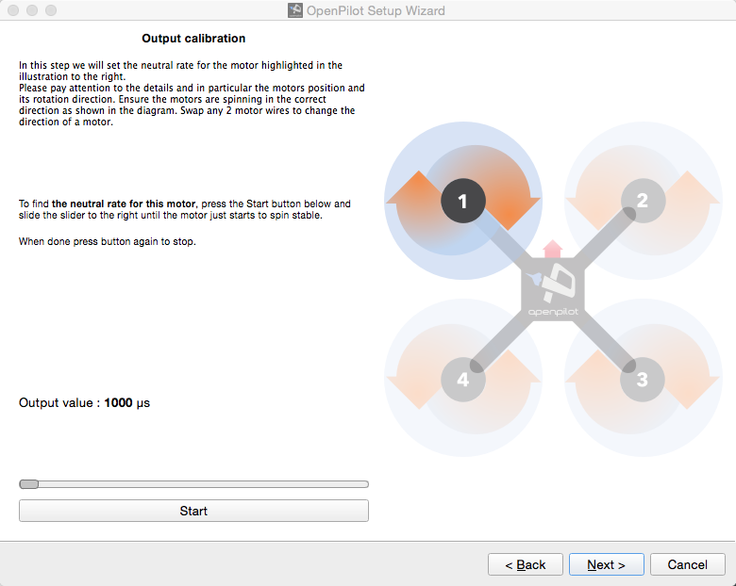

Now the wizard will calibration the output of the highlighted motor in the diagram. Please double check if the motor’s rotating direction is the same as showing in the diagram. If a motor is reversed just swap any two wires comes from ESC to the motor.

Follow the instructions to find the neutral rate of the first motor and click “Next”, then do the same for the rest three motors. Click “Next” to continue.
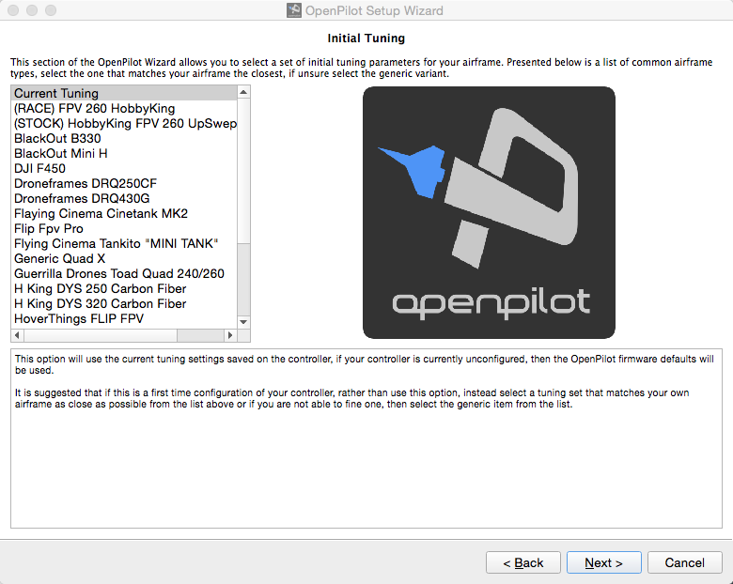

Use the default setting here unless you know what you are doing, then click “Next”

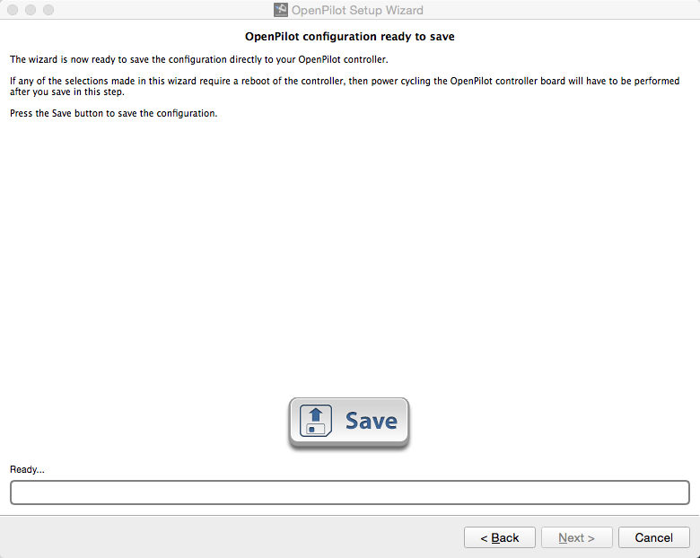
Click the “Save” button to save all previous settings.
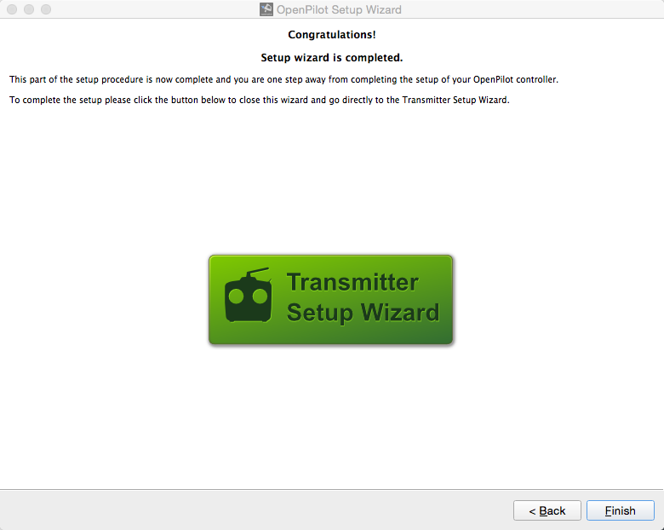
Click “Finish” and back to the home page:
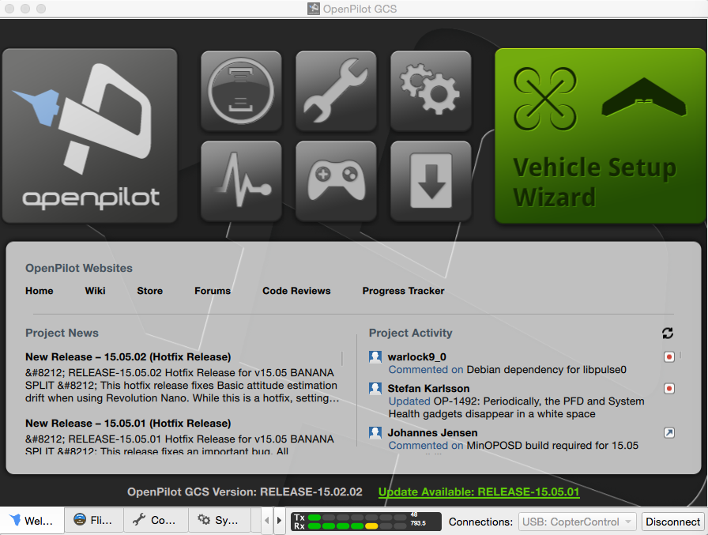

Now the basic setup of CC3D is completed, we need to double check that everything is done correctly. Click “Configuration” tab at the bottom and have a look at the “HW Settings”

  - If you’ve chosen PWM receiver in the wizard:

Click “Hardware” tab on left, check the Flexi Port and Main Port settings and make sure they are the same as the screenshot below. If there’s any difference please change accordingly and click “Save”.

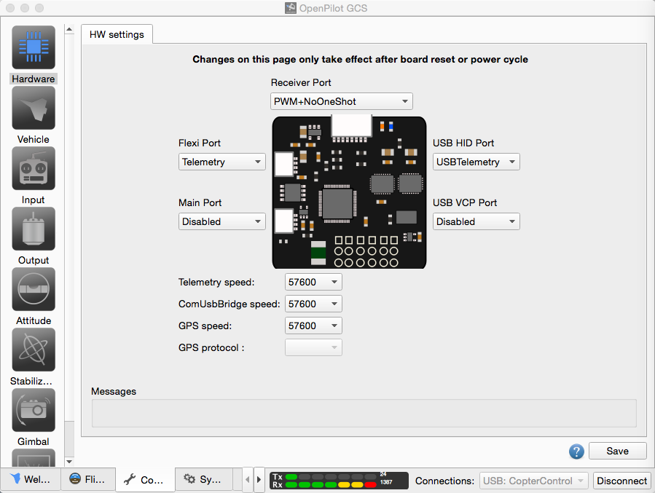

  - If you’ve chosen PPM receiver in the wizard:

Click “Hardware” tab on left, check the Flexi Port and Main Port settings and make sure they are the same as the screenshot below. If there’s any difference please change accordingly and click “Save”.

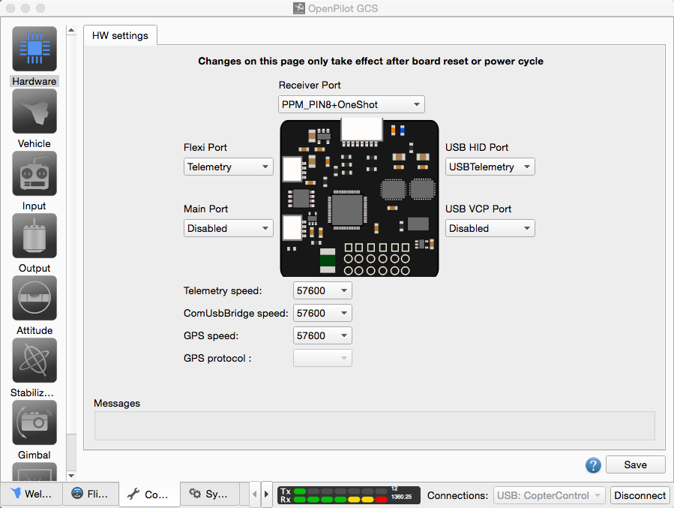

  - If you’ve chosen S.Bus receiver the wizard:

Click “Hardware” tab on left, check the Flexi Port and Main Port settings and make sure they are the same as the screenshot below. If there’s any difference please change accordingly and click “Save”.

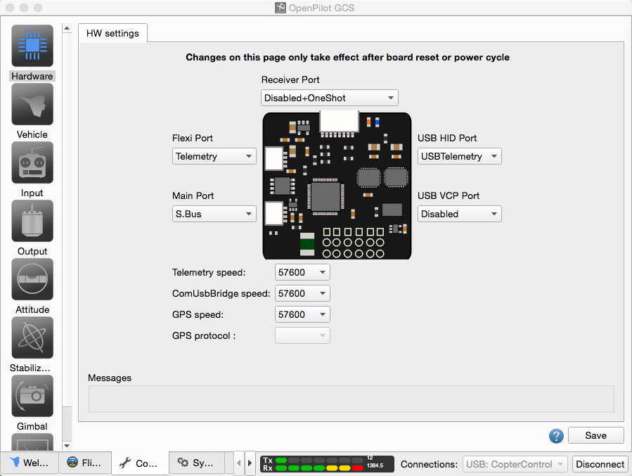

  - If you’ve chosen DSM receiver in the wizard, there are TWO things to check:

  - Click “Hardware” tab on left, check the Flexi Port and Main Port settings and make sure they are the same as the screenshot below. If there’s any difference please change accordingly and click “Save”.
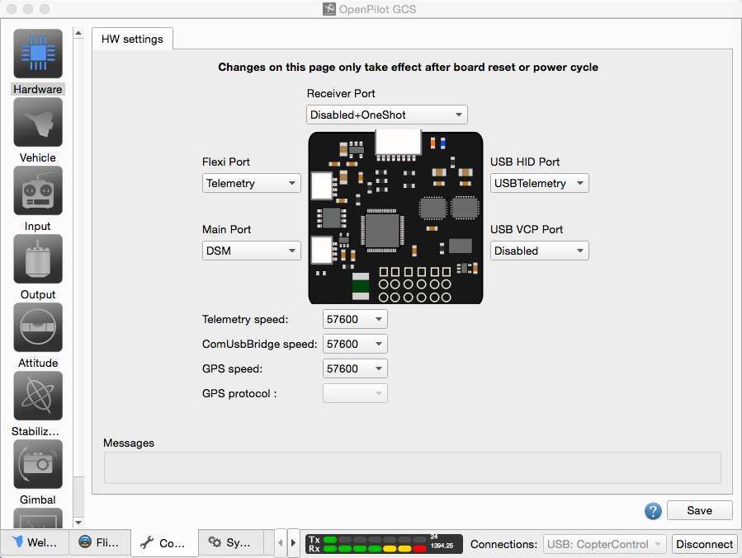

  - 2: Click “Input” tab on the left, and click “RC Input” tab you should see the following page, double check if the contents under “Input Channel Configuration” section are the same as the screenshot below, If there’s any difference please change accordingly and click “Save”.

Now it’s time to calibrate the radio, click “Input” tab on the left and click on “Start Transmitter Setup Wizard”. 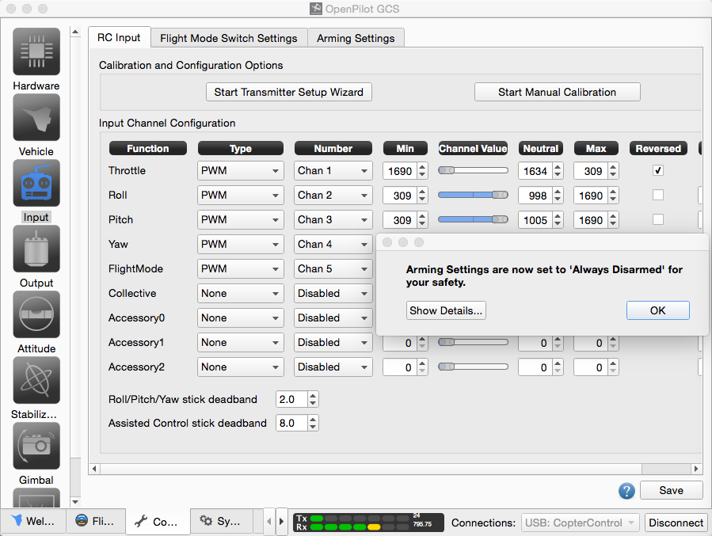
Accept the safety notice by click “OK”

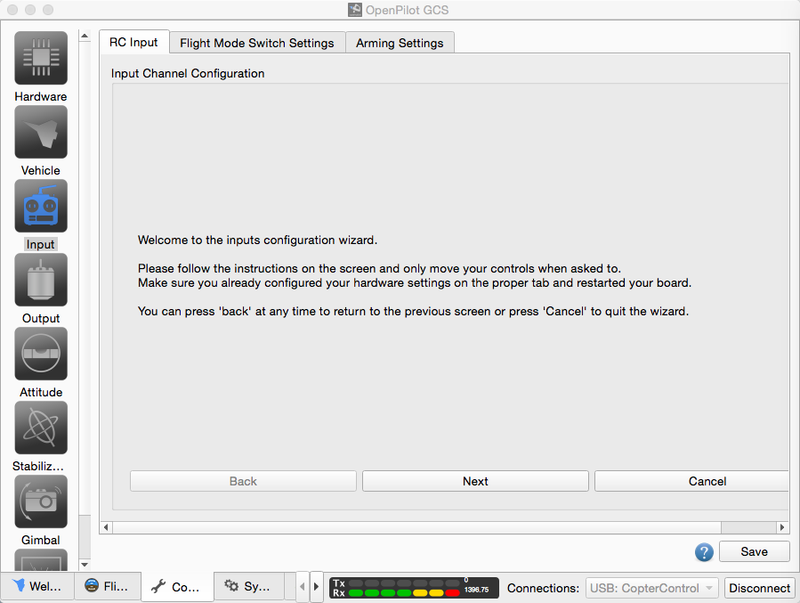
Click “Next”：
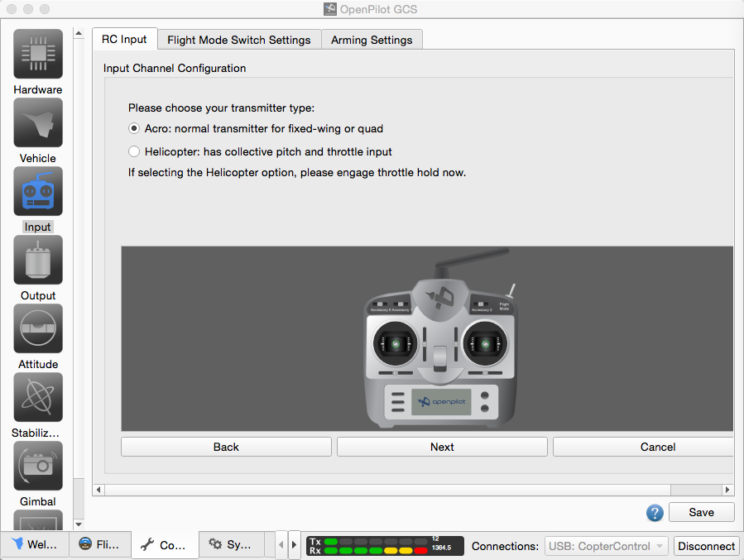

Select “Acro” then click “Next”
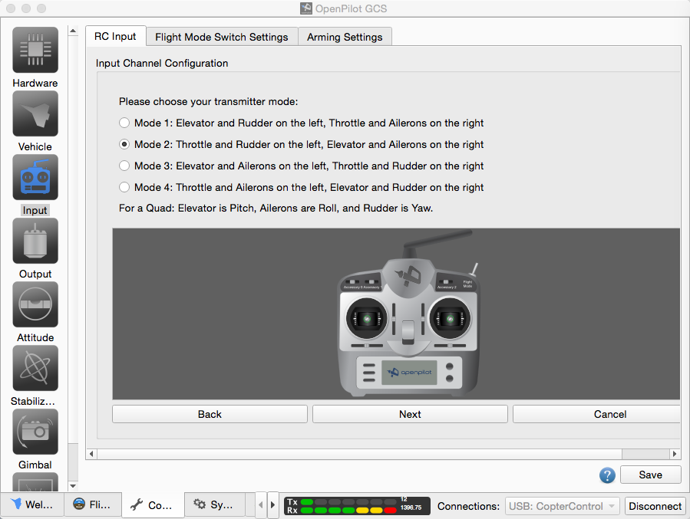

Select the correct mode according to your transmitter and click “Next”, carefully follow the screen prompt until the calibration finish. Make sure you fully understand the arming process and select the preferred arming combination under “Arming Settings”. Don’t forget to click “Save” to save all the settings.

Click “Attitude” tab from the left, and make sure you put “180” into the “Roll” setting. This is very important, failing to do so will cause an instant crash on your first flight.

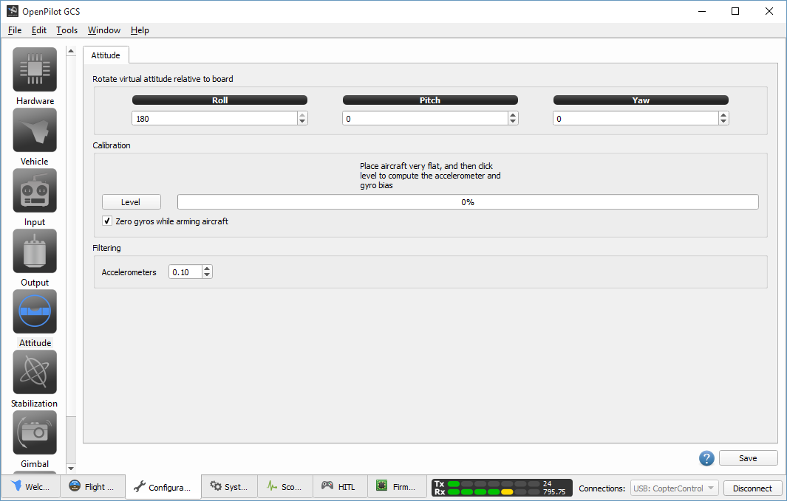

Click “Flight data” tab from the bottom bar, check the hud and make sure it corectly reflect all the movements of the Kylin 250 FPV.

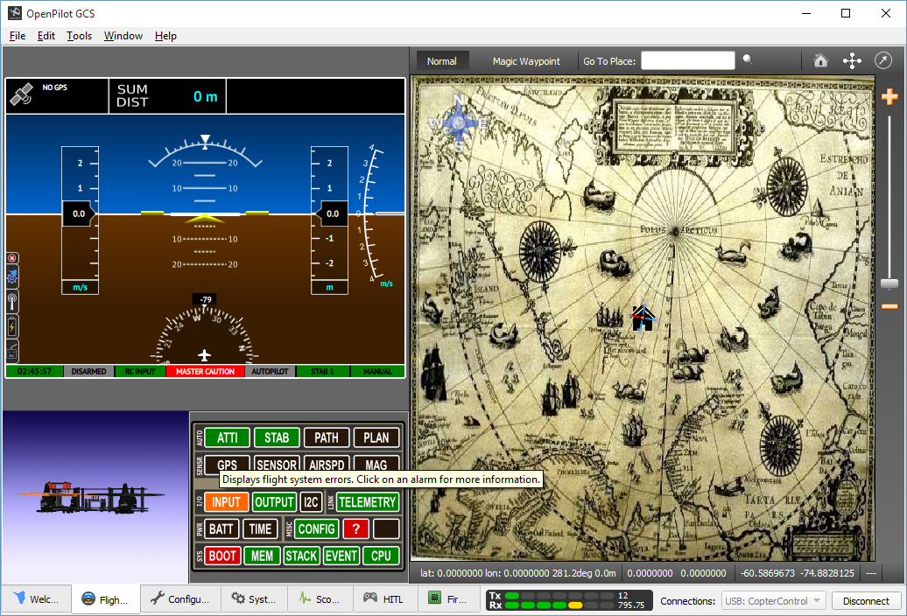

您己完全所有FPV的设置并可以尝试飞行，请注意如下事项：
- 试飞时请到空旷的地方，并远离人群和建筑物；
- 远离水源和高压线；
- 正确安装螺旋桨叶，左前和右后马达为5045或5040桨叶，右前和左下马达为5045R或5040R
- 5.8G图传必须在通电前装好天线，否则有烧毁图传的可能；
- 首先打开遥控器开关，再接通电源，将FPV机体放在平稳的地方，直到FPV指示灯由快闪转变为慢闪后才能用遥控进行解锁；
- 缓慢推动油门直到机体平稳升空；

Now you have completed all the CC3D flight controller settings and ready for a test fly. Here is a list of very important things to remember before takeoff:

- Select a suitable site that is away from tall buildings, high trees, power lines, water and crowds, especially children;
- Put on the propellers correctly according to the setup. The Kylin 250 FPV use 5040 or 5045 size propellers, 2 clockwise and 2 counter clockwise.
- Ensure the TX mushroom antenna is connected to the 5.8G video transmitter BEFORE connecting the main battery, otherwise the video transmitter may burn out very quickly.
- Put the Kylin 250 FPV on a flat surface, switch on the transmitter first then connect the main battery, keep the FPV flat and secure while the flight controller is initializing, after the BLUE LED changes from rapid flashing into slow blink, you are ready to arm it with the transmitter.
- Gently and smoothly increate the throttle until the FPV took off, confirm the roll, pitch and yaw movements are all correct by slowly moving the corresponding sticks, then fly as wish after get used to the control.

Warning:
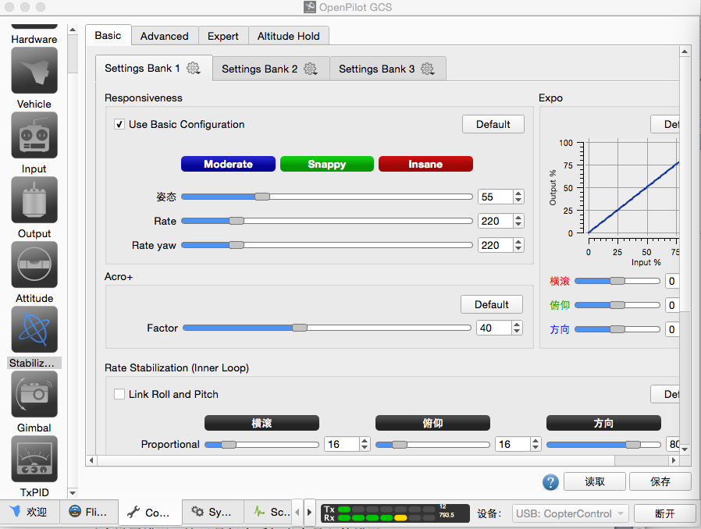

Please DO NOT modify the above settings unless you are familiar with CC3D and knows what you are doing. Saved misconfigure may cause hardware issues that beyond end user’s reparability and can only be fixed by PCB replacement.

PCB layout & socket pinout:
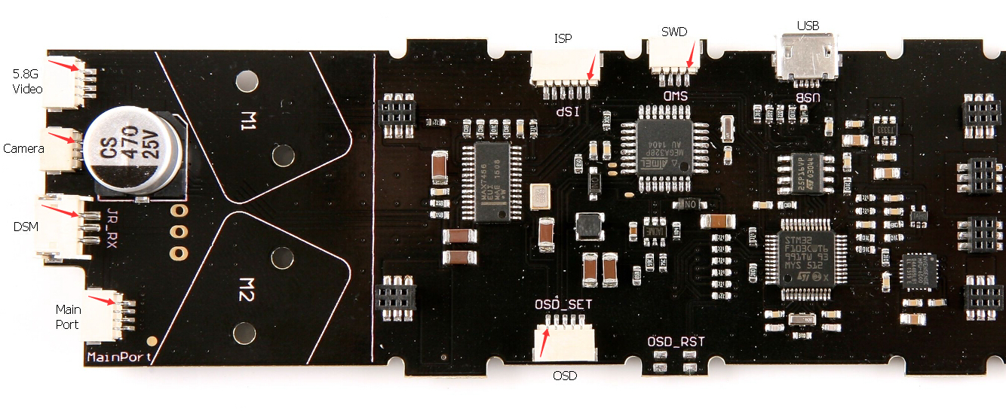
Note: Red arrows indicating the pin1

5.8G Video TX Interface

1：GND
2：VCC
3：GND
4：Video In

Camera Interface

1：VCC
2：GND
3：Video Out

DSM Interface

1：3.3V VCC
2：GND
3：Signal

Main Port Interface

1：GND
2：5V VCC
3：TX
4：RX

OSD Setup Interface

1：TDR reset
2：TX
3：RX
4：5V VCC
5：GND

ISP Interface

1: MOSI
2: MISO
3: SCK
4: RESET
5: 5V VCC
6: GND

SWD Interface

1：IO
2：CLK
3：3.3V VCC
4：GND

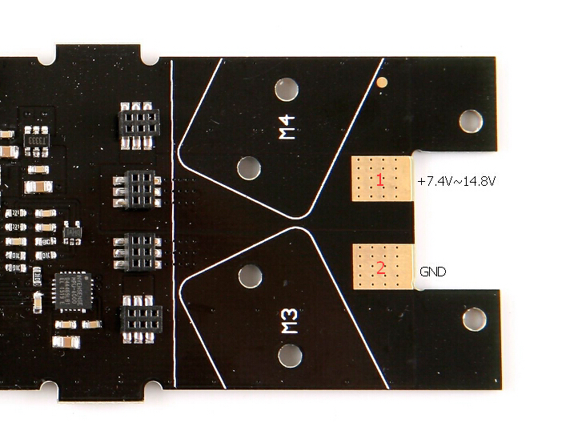
Main Power Connection

1：VCC 7.4V~14.8V
2：GND

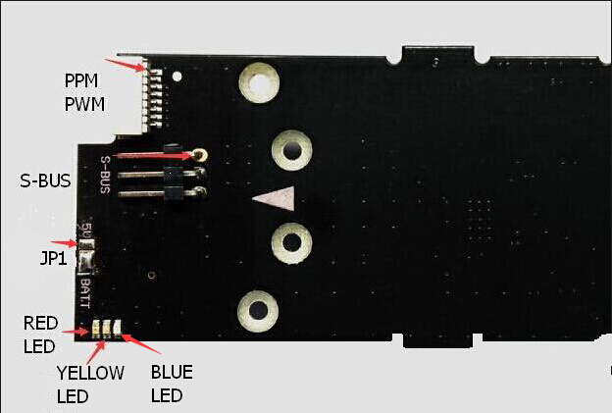

PPM PWM Interface

1：GND
2：5V VCC
3：AIL
4：ELE
5：THR
6：RUD
7：AUX 1
8：AUX 2/PPM

S.Bus Interface

1：GND
2：5V VCC
3：Signal

JP1 Jumper (To setup the power voltage to the camera)

1 - 2 short: 5V
2 - 3 short: Main Battery Voltage

Note: The default setting is Main Battery Voltage, never short 1 2 and 3 together as that will burn the control board.

LED Indicator:

Red LED：
Power indicator. ON solid when the main battery is connected or connected to computer via USB.

Yellow LED：
OSD states indicator. Flashing constant when OSD is working fine.

Blue LED:
Control board status indicator. Flashing fast when the power is connected and the CC3D is initializing, DO NOT move the FPV when this light is flashing fast. After the flashing becomes slow you can move the FPV around or just arm and fly.

Restore Factory Default Settings:

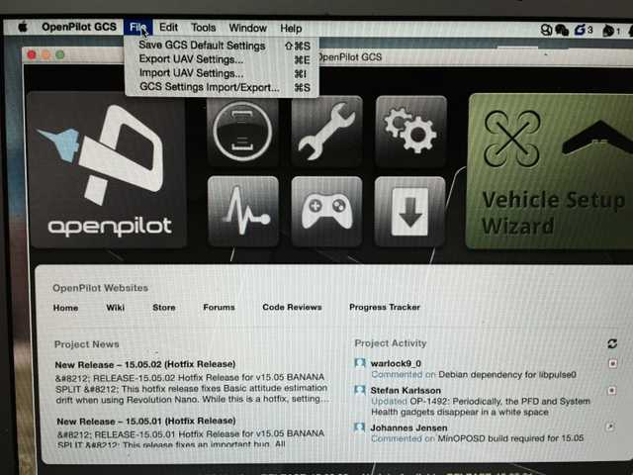
From the main interface, click the “File” menu and select “Import UAV Settings”

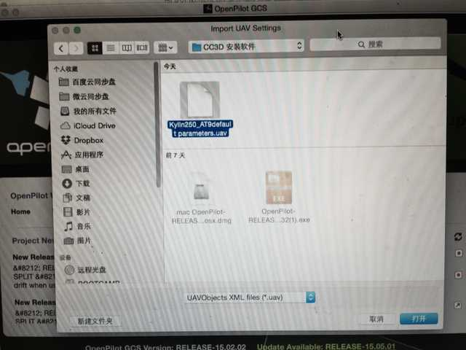

Browse your computer to the file: Kylin250_AT9default parameters.uav and click “Open”

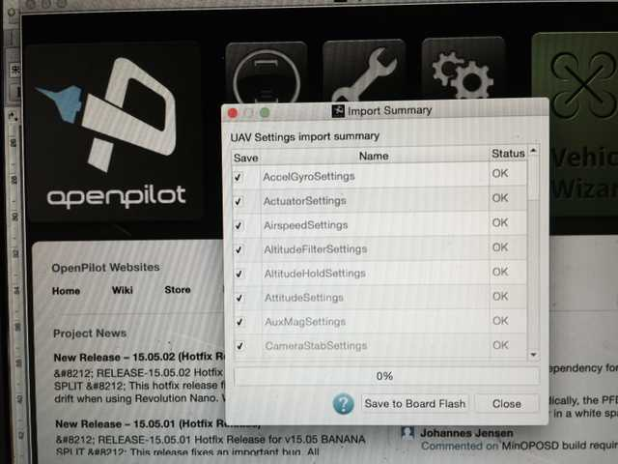
Click “Save to Board Flash”, close it after the progress bar shows 100% done. Your Kylin 250 FPV is now back to factory default setup to work with the KDS AT-9 transmitter only, if you are using other transmitters, you will need to change some configurations according to this manual.

